CTF Write-up: Thomas-schools-of-China (Forensics)

Overview
This challenge involved the recovery of a hidden flag from a custom-formatted binary file (.tsc). The objective was to perform file signature identification, manual header analysis, and data sanitization to retrieve the embedded plaintext flag.
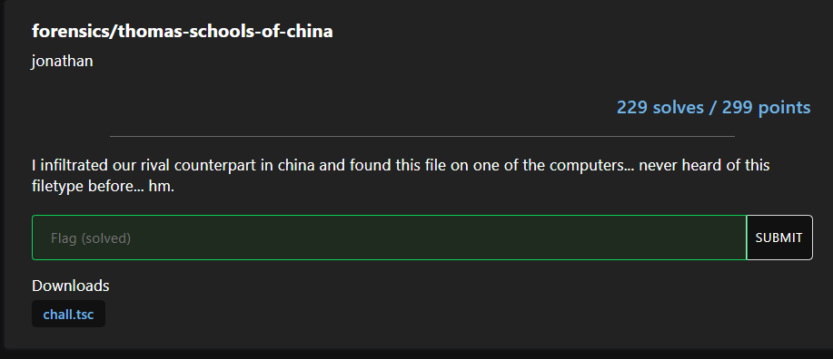The challenge provided an unfamiliar file format, requiring the investigator to bypass obfuscation layers to recover the hidden artifact and reconstruct the flag.

Description
I infiltrated our rival counterpart in china and found this file on one of the computers... never heard of this filetype before... hm.

Strategy
Header Signature Verification: Utilizing file and hexdump to identify the non-standard TSCF header.
Obfuscation Analysis: Investigating the file for injected noise patterns that were designed to hinder automated recovery.
Data Sanitization: Cleaning the extracted string to remove noise patterns (kkktttu, CCCOOO, 666}) to reconstruct the valid flag format.

Solving Steps

Signature Identification
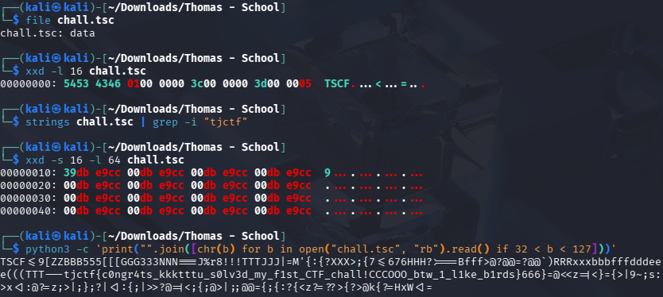
This image confirms the initial reconnaissance. By running the file command, I demonstrated that the binary lacks a standard file signature (returning only 'data'), which immediately alerted me to the presence of an obfuscation layer."


This screenshot highlights the hex header analysis. Identifying the 'TSCF' magic bytes provided the specific evidence needed to categorize this as a custom, non-standard container rather than a corrupted file

Artifact Extraction



This captures the header-stripping process. Using dd, I bypassed the 4-byte obfuscation header. This critical step was required to expose the underlying data structure, which was inaccessible as long as the custom header remained in place

This shows the result of the extraction. By verifying the binary stream following the header removal, I confirmed that the file contained hidden, obfuscated plaintext, effectively isolating the flag-bearing artifact."

Sanitization and Recovery

This final image displays the raw extracted output before sanitization. It visualizes the 'noise'—the injected kkktttu, CCCOOO, and 666} padding—that I identified as intentional obfuscation. This provides visual proof of the noise patterns that needed to be cleaned to recover the valid flag string.

Flag
tjctf{c0ngr4ts_u_s0lv3d_my_f1st_CTF_chall!_btw_1_l1ke_b1rds}

